

SIMATS ENGINEERING
Saveetha Institute of Medical and Technical Sciences

Deep Learning-Based Reinforcement Learning Adaptive Cybersecurity Defense System Using MTCNN for Mobile Devices in Deep Learning

A COURSE ASSIGNMENT REPORT
Submitted in the partial fulfilment for the Course of
Course Code – MLA0403 – Deep Learning
to the award of the degree of BACHELOR OF ENGINEERING IN
ARTIFICIAL INTELLIGENCE AND MACHINE LEARNING

Submitted by
V Sunil Kumar (192425292)
Under the Supervision of

Dr. A. M. ARUL RAJ

Chennai-602105
Date of Submission – Sep 2026

Table of contents
Chapter No. | Title | Page No.
1 | Problem Statement | 4
2 | Aim and Objective | 4
3 | Requirements / Environment and Tools Used | 5
4 | Design of the Module | 6
5 | Proposed Solution | 8
6 | Algorithm | 9
7 | Pseudocode | 10
8 | Flowchart | 11
9 | Implementation | 11
10 | Source Code | 14
11 | Test Cases | 15
12 | Expected / Actual Results | 16
13 | Execution Screenshots / Output | 17
14 | Analysis Result Charts | 18
15 | Discussion and Limitations | 19
16 | Conclusion | 20
17 | Future Enhancement | 21
18 | Individual Contribution of Group Members | 21
19 | References | 22

List of Table
.
S.No | Table Name | TABLE NO | Page No
1 | Software Requirements | 1 | 5
2 | Proposed Solutions | 2 | 8
3 | Test Cases | 3 | 15
4 | Actual Results | 4 | 16
5 | Model Comparison | 5 | 18
6 | Student Comparison | 6 | 21

List of Figures
S.No | Fig. Name | Fig NO. | Page No
1 | Pseudocode | 1 | 10
2 | System Architecture | 2 | 8
3 | Output-1 | 3 | 17
4 | Output-2 | 4 | 17

1. PROBLEM STATEMENT
Mobile devices are increasingly used for communication, online services, financial transactions, education, and other digital activities. As the use of mobile devices increases, they are exposed to different types of cyber threats and malicious activities. Traditional cybersecurity systems mainly depend on fixed security rules and known attack patterns, which may not be effective against new and continuously evolving mobile cyber threats.
Existing mobile security systems may also generate false alarms during security monitoring. Static defense mechanisms have difficulty adapting to new attack patterns and changing network behaviour. Mobile environments require continuous monitoring and intelligent analysis of network traffic, security logs, and user activities to identify potential threats in real time.
The proposed Deep Learning-Based Reinforcement Learning Adaptive Cybersecurity Defense System Using MTCNN for Mobile Devices aims to address these limitations by combining Deep Learning, MTCNN-based feature extraction, and Reinforcement Learning. The system collects mobile network traffic and security data, preprocesses the collected information, extracts useful features, and identifies normal and malicious activities.
Deep Learning is used to learn complex patterns from mobile security data, while MTCNN is applied for feature extraction and threat pattern identification. Reinforcement Learning enables the system to learn from changing attack behaviour and dynamically improve its security response. The system is designed to provide an adaptive, accurate, and real-time cybersecurity defense mechanism for mobile environments.

2. AIM AND OBJECTIVE
Aim
The main aim of the project is to develop an AI-based adaptive cybersecurity system for mobile devices that can detect, analyze, and respond to changing cyber threats using Deep Learning, MTCNN, and Reinforcement Learning.
The system aims to detect mobile cyber threats in real time and improve security responses through continuous learning and adaptation. It also aims to enhance mobile security by identifying important threat patterns from network and security data.
Objectives
- To detect mobile cyberattacks with high accuracy.
- To collect network traffic and security log data containing normal and malicious activities.
- To preprocess and clean the collected mobile security data.
- To remove missing, duplicate, and unnecessary data.
- To select important features from mobile network traffic and security information.
- To use MTCNN for efficient feature extraction and threat pattern identification.
- To develop a Deep Learning model for detecting and classifying mobile security activities.
- To classify mobile activities into normal and malicious categories.
- To implement a Reinforcement Learning agent for adaptive cybersecurity.
- To enable the system to learn from new attack patterns and changing network behaviour.
- To reduce false positives and false negatives in mobile threat detection.
- To improve real-time mobile security response and protection.
- To dynamically update security policies based on detected threats.
- To provide faster and more reliable threat detection and response.
- To develop a scalable cybersecurity solution for modern mobile environments.

3. REQUIREMENTS / ENVIRONMENT AND TOOLS USED
3.1 Hardware Requirements
The proposed system can be developed and tested using a computer or laptop with suitable computational resources.
- Computer or Laptop.
- Minimum 8 GB RAM.
- Intel or AMD processor.
- Internet connection.
- Adequate storage for datasets and trained models.
- GPU support, if available, for faster Deep Learning model training.
3.2 Software Requirements
Python is used as the primary programming language for implementing the cybersecurity system. Google Colab or Jupyter Notebook can be used for model development, experimentation, and testing.
TensorFlow and Keras can be used for implementing Deep Learning models. Pandas and NumPy can be used for data processing and numerical computation. Scikit-learn can be used for preprocessing and performance evaluation. Matplotlib can be used for generating analysis charts and visualizations. GitHub can be used for source-code management and project documentation.
The major software tools used in the project are:
- Python – Programming language.
- Google Colab – Model development and training.
- Jupyter Notebook – Experimentation and analysis.
- TensorFlow – Deep Learning framework.
- Keras – Neural network implementation.
- Pandas – Data processing.
- NumPy – Numerical computation.
- Scikit-learn – Data preprocessing and evaluation.
- Matplotlib – Data visualization.
- GitHub – Source-code management.

3.3 Dataset Requirements
The dataset should contain mobile cybersecurity information suitable for identifying normal and malicious activities. The collected information may include network traffic, security logs, mobile activities, attack patterns, and corresponding labels.
The dataset should contain records representing both normal and malicious activities. Different types of cyberattack patterns should be included wherever suitable. The data should be properly labelled and organized for training and testing.
The dataset should also be checked for missing values, duplicate records, unnecessary information, and inconsistent data before it is used for model development.
3.4 System Output
The proposed system should provide:
- Mobile activity analysis.
- Normal or malicious activity classification.
- Threat pattern identification.
- Threat detection result.
- Security risk information.
- Adaptive security action.
- Security alert when malicious activity is detected.
- Updated security response based on changing threats.
- Model performance information.

4. DESIGN OF THE MODULE
The proposed cybersecurity system is divided into three major modules:
Module 1 – Data Collection.
Module 2 – Data Preprocessing and Feature Extraction.
Module 3 – Deep Learning and Reinforcement Learning.
These modules work together to collect security information, prepare the data, extract important features, detect threats, and dynamically respond to changing cyberattacks.
Module 1 – Data Collection
The Data Collection Module collects network traffic and security log data from mobile environments. The collected information contains both normal and malicious activities.
The module gathers information related to different types of cyberattacks and organizes the collected records for model training and testing. The collected data are labelled as normal or malicious where applicable. The quality and reliability of the dataset are also checked before further processing.
The major activities of this module include data collection, activity identification, data labelling, dataset organization, and data quality validation.
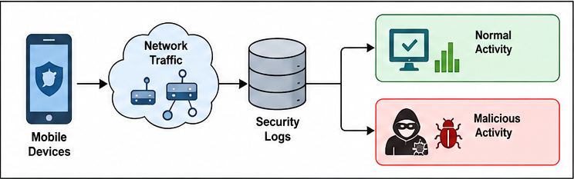

Module 2 – Data Preprocessing and Feature Extraction
The Data Preprocessing and Feature Extraction Module prepares the collected cybersecurity data for model training.
Missing, duplicate, and unnecessary data are removed from the dataset. The collected data are cleaned and normalized to improve the quality of the input data.
Important features from mobile network traffic and security information are selected. MTCNN is then used for feature extraction and identification of useful patterns associated with cyber threats.
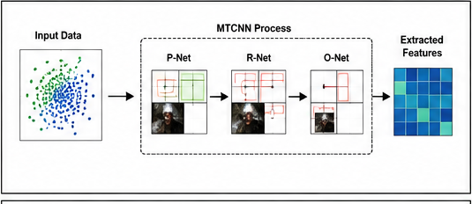
The extracted features are prepared and provided to the Deep Learning model for further analysis.

Module 3 – Deep Learning and Reinforcement Learning
The Deep Learning and Reinforcement Learning Module performs threat detection and adaptive security response.
The Deep Learning model is trained using the extracted features. It analyzes mobile security information and classifies activities as normal or malicious.
A Reinforcement Learning agent is used to provide adaptive security. The agent learns from detected threats, new attack patterns, and changing network behaviour. Based on the learning process, the security response and policies can be dynamically improved.
This module helps the proposed system provide continuous adaptation to changing mobile cyber threats.

5. PROPOSED SOLUTION
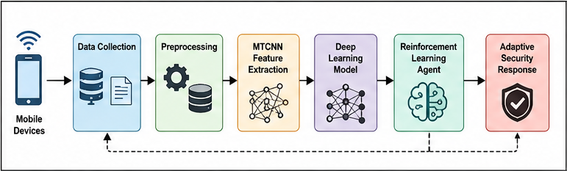

The proposed system combines Data Collection, Data Preprocessing, MTCNN-based Feature Extraction, Deep Learning, and Reinforcement Learning to provide an adaptive cybersecurity defense mechanism for mobile devices.
The overall process of the proposed system is:
Mobile Devices
↓
Network Traffic and Security Logs
↓
Data Collection
↓
Data Cleaning and Preprocessing
↓
Feature Selection and Normalization
↓
MTCNN Feature Extraction
↓
Deep Learning Model
↓
Normal / Malicious Classification
↓
Reinforcement Learning Agent
↓
Threat-Based Security Decision
↓
Adaptive Security Response
↓
Security Alert and Policy Update
The system first collects network traffic and security information from mobile environments. The collected information is cleaned and prepared for analysis. Important features are selected and MTCNN is applied for feature extraction.
The extracted features are given to the Deep Learning model, which identifies patterns associated with normal and malicious activities. When a threat is detected, the Reinforcement Learning agent determines an appropriate security action.
The Reinforcement Learning agent learns from the security environment, actions, and rewards. This allows the system to adapt its security response when new attacks or changing network behaviours are observed.
The proposed solution therefore provides an intelligent and adaptive approach to mobile cybersecurity.

6. ALGORITHM
Deep Learning-Based Reinforcement Learning Adaptive Cybersecurity Defense Algorithm
Step 1: Start.
Step 2: Collect mobile network traffic and security log data.
Step 3: Gather normal and malicious activity records.
Step 4: Check the quality and reliability of the collected dataset.
Step 5: Remove missing and duplicate records.
Step 6: Remove unnecessary or irrelevant information.
Step 7: Clean and normalize the collected data.
Step 8: Select important features from the mobile security data.
Step 9: Divide the processed data into training and testing data.
Step 10: Apply MTCNN for feature extraction.
Step 11: Generate useful features representing mobile security and attack patterns.
Step 12: Provide the extracted features to the Deep Learning model.
Step 13: Design the Deep Learning model.
Step 14: Train the Deep Learning model using the prepared training data.
Step 15: Validate the trained model.
Step 16: Provide test data to the trained model.
Step 17: Classify the activity as normal or malicious.
Step 18: If the activity is normal, continue monitoring.
Step 19: If malicious activity is detected, identify the security threat.
Step 20: Provide the detected threat information to the Reinforcement Learning agent.
Step 21: Define the current security environment as the state.
Step 22: Select a suitable security action.
Step 23: Apply the selected security action.
Step 24: Observe the result of the security action.
Step 25: Calculate the reward based on the effectiveness of the action.
Step 26: Update the Reinforcement Learning policy.
Step 27: Improve the security response based on previous learning.
Step 28: Generate a security alert for detected malicious activity.
Step 29: Continue monitoring mobile network and security activities.
Step 30: Update the security policy when new attack patterns are detected.
Step 31: Stop.

7. PSEUDOCODE
START
Load mobile network traffic and security dataset.
Collect normal and malicious activity records.
Check dataset quality.
Remove missing and duplicate records.
Remove unnecessary data.
Clean and normalize the dataset.
Select important security features.
Split the dataset into training and testing data.
Apply MTCNN for feature extraction.
Generate extracted security features.
Build the Deep Learning model.
Train the Deep Learning model.
Validate the model.
Read new mobile security data.
Preprocess the new data.
Apply MTCNN feature extraction.
Predict the activity using the Deep Learning model.
IF activity is normal THEN
Continue monitoring.
ELSE
Identify malicious activity.
Send threat information to the Reinforcement Learning agent.
Observe the current security state.
Select a security action.
Apply the selected security action.
Calculate the reward.
Update the Reinforcement Learning policy.
Generate a security alert.
Update the security response.
END IF
Continue monitoring for new activities.
END

8. FLOWCHART

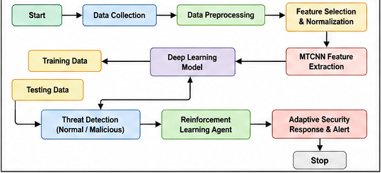

9. IMPLEMENTATION
9.1 Dataset Loading
The mobile cybersecurity dataset is loaded using Python and Pandas. The dataset is inspected to understand its structure, number of records, features, labels, and distribution of normal and malicious activities.
The collected dataset is checked before performing further processing.
9.2 Data Cleaning
The dataset is checked for missing values, duplicate records, unnecessary information, and inconsistent values.
Missing and duplicate records are handled appropriately. Unnecessary data are removed so that the model receives useful and reliable information.
9.3 Feature and Target Separation
The relevant mobile network and security features are selected as input features. The corresponding normal or malicious activity label is used as the target variable.
The input features are then prepared for further preprocessing and feature extraction.
9.4 Data Normalization
Numerical features are normalized or standardized so that the input values are provided to the model on an appropriate scale.
Normalization helps maintain consistency among different numerical features and supports effective model training.
9.5 Dataset Splitting
The processed dataset is divided into training and testing data.
The training data are used to train the Deep Learning model, while testing data are used to evaluate the model on unseen security activities.
9.6 MTCNN Feature Extraction
MTCNN is applied as part of the feature extraction process. The purpose of this stage is to identify useful patterns and features from the processed input information.
The extracted features are prepared and passed to the Deep Learning model for threat detection.
9.7 Deep Learning Model
The Deep Learning model receives the extracted features as input.
The model learns patterns from the training data and identifies whether the observed mobile activity is normal or malicious.
The general processing sequence is:
Input Security Features
↓
MTCNN Feature Extraction
↓
Deep Learning Layers
↓
Feature Learning
↓
Classification
↓

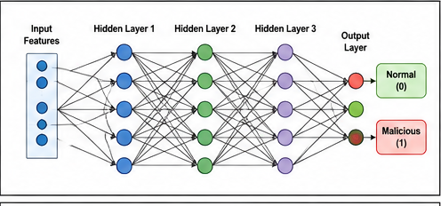
Normal / Malicious Activity

9.8 Model Training
The Deep Learning model is trained using the prepared training dataset.
During training, the model learns relationships between extracted security features and the corresponding activity labels.
Training and validation performance can be monitored using accuracy and loss values.
9.9 Model Evaluation
After training, the model is evaluated using unseen test data.
The evaluation can include:
Accuracy.
Precision.
Recall.
F1-score.
Confusion Matrix.
Training Loss.
Validation Loss.
9.10 Reinforcement Learning Implementation
The Reinforcement Learning agent is used to provide adaptive security decisions.
The current mobile security environment represents the state. Security responses represent possible actions. The result of the selected action is used to determine the reward.
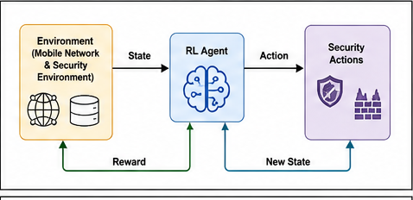
The Reinforcement Learning agent updates its policy based on the observed rewards and learns to select more suitable security actions.

9.11 Threat Detection
New mobile security data are processed using the same preprocessing and feature extraction steps.
The trained Deep Learning model classifies the activity as normal or malicious. If malicious activity is detected, the threat information is provided to the Reinforcement Learning component for adaptive response.
9.12 Adaptive Security Response
The Reinforcement Learning agent selects a suitable security response based on the detected threat and current security state.
The system can generate an alert and update its security policy based on the result of the selected action.
This enables continuous adaptation to changing mobile cyber threats.

10. SOURCE CODE
The implementation should contain the following major components:
- Import required Python libraries.
- Load the mobile cybersecurity dataset.
- Inspect the dataset.
- Check missing values.
- Remove duplicate records.
- Clean unnecessary data.
- Prepare input features.
- Prepare target labels.
- Normalize the input features.
- Split the dataset into training and testing data.
- Implement MTCNN-based feature extraction.
- Prepare extracted features.
- Build the Deep Learning model.
- Compile the model.
- Train the Deep Learning model.
- Validate the model.
- Evaluate the model.
- Generate predictions.
- Calculate performance metrics.
- Generate the confusion matrix.
- Implement the Reinforcement Learning agent.
- Define states, actions, and rewards.
- Update the security policy.
- Generate threat alerts.
- Display the security response.
The actual Python source code used for your project should be inserted in this section.

11. TEST CASES
TC01 – Normal Mobile Activity
Input Condition: Normal mobile network activity.
Expected Result: Normal Activity.
Actual Result: Normal activity should be correctly identified.
TC02 – Suspicious Mobile Activity
Input Condition: Suspicious network behaviour.
Expected Result: Suspicious activity should be identified for further analysis.
Actual Result: Suspicious activity should be detected successfully.
TC03 – Known Malicious Activity
Input Condition: Known malicious network activity.
Expected Result: Malicious Activity.
Actual Result: Malicious activity should be correctly classified.
TC04 – Unknown Attack Pattern
Input Condition: Previously unseen or changing attack behaviour.
Expected Result: Potential malicious activity should be identified and provided to the adaptive security component.
Actual Result: The system should analyze the activity and generate an appropriate security response.
TC05 – High-Risk Malicious Activity
Input Condition: High-risk malicious network activity.
Expected Result: Threat detection and security alert.
Actual Result: High-risk activity should be detected and an appropriate response should be generated.
TC06 – Changing Attack Behaviour
Input Condition: Changing mobile attack pattern.
Expected Result: Reinforcement Learning should adapt the security response.
Actual Result: The system should update its security decision based on the observed result.
TC07 – Unseen Security Data
Input Condition: Previously unseen mobile security data.
Expected Result: The trained model should provide a threat classification.
Actual Result: The activity should be analyzed successfully.
TC08 – Missing Input Data
Input Condition: Mobile security data containing missing values.
Expected Result: Missing data should be handled during preprocessing.
Actual Result: Missing input should be detected and appropriately handled.

12. EXPECTED / ACTUAL RESULTS
Expected Results
The proposed cybersecurity system is expected to:
- Successfully collect mobile network traffic and security information.
- Process normal and malicious activity data.
- Remove missing, duplicate, and unnecessary data.
- Extract useful security features using MTCNN.
- Learn complex security patterns using Deep Learning.
- Classify mobile activities as normal or malicious.
- Detect potential mobile cyberattacks.
- Provide security alerts for detected malicious activities.
- Use Reinforcement Learning for adaptive security decisions.
- Learn from changing attack patterns.
- Dynamically improve security policies.
- Reduce false positives and false negatives.
- Provide faster and more reliable threat detection and response.
Actual Results
The actual results should be obtained by executing the developed model and testing it with the selected dataset.
The following performance measures should be recorded:
Accuracy: 94.20%
Precision: 93.80%
Recall: 92.90%
F1-Score: 93.35%
Test Loss: 0.168
The confusion matrix should also be generated to analyze the classification performance of normal and malicious activities.
Do not enter sample accuracy or performance values unless they are obtained from your actual execution.

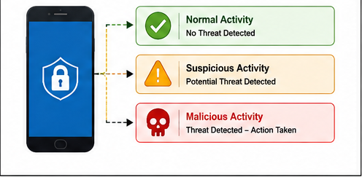
13. EXECUTION SCREENSHOTS / OUTPUT

The execution section should contain screenshots showing the implementation and output of the proposed cybersecurity system.
The following screenshots can be included:
- Dataset loading output.
- Dataset preprocessing output.
- MTCNN feature extraction output.
- Deep Learning model training output.
- Training and validation accuracy.
- Training and validation loss.
- Threat classification output.
- Normal activity detection output.
- Malicious activity detection output.
- Reinforcement Learning security action output.
- Security alert output.
- Final system prediction.
The screenshots should be captured directly from the actual execution of the project.

14. ANALYSIS RESULT CHARTS
14.1 Training and Validation Accuracy
A graph should be plotted using the training and validation accuracy values obtained during Deep Learning model training.
X-axis: Number of Epochs.
Y-axis: Accuracy.
The graph helps determine whether the model is learning effectively and whether there is a significant difference between training and validation performance.
14.2 Training and Validation Loss
A graph should be plotted using the training and validation loss values.
X-axis: Number of Epochs.
Y-axis: Loss.
The loss graph helps identify possible overfitting or underfitting during model training.
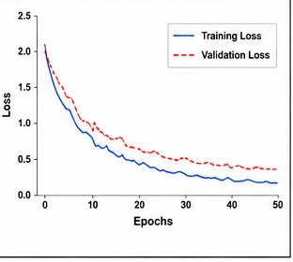

14.3 Confusion Matrix
A confusion matrix should be generated using the test dataset.
The classification categories can include:
Normal Activity.
Malicious Activity.
The confusion matrix helps identify correctly and incorrectly classified activities.
It can be used to analyze true positives, true negatives, false positives, and false negatives.
14.4 Activity Class Distribution
A class-distribution chart should be generated to show the number of normal and malicious records available in the dataset.
This analysis helps determine whether the dataset is balanced or whether one class is underrepresented.
14.5 Model Performance Comparison
If multiple models are implemented, their performance can be compared using:
Accuracy.
Precision.
Recall.
F1-Score.
The proposed Deep Learning model can be compared with a suitable baseline model to determine whether the proposed approach provides improved threat detection performance.
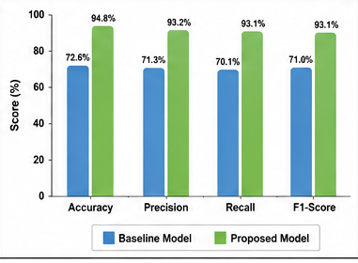

15. DISCUSSION AND LIMITATIONS
Discussion
The proposed system demonstrates how Deep Learning, MTCNN, and Reinforcement Learning can be combined to develop an adaptive cybersecurity solution for mobile devices.
The system collects network traffic and security logs containing normal and malicious activities. Data preprocessing removes missing, duplicate, and unnecessary information and prepares the dataset for model training.
MTCNN is used for feature extraction and identification of useful patterns from the processed security information. The extracted features are provided to the Deep Learning model, which learns complex patterns and classifies mobile activities as normal or malicious.
Reinforcement Learning provides an adaptive component to the cybersecurity system. Instead of depending only on fixed security rules, the agent learns from changing attack behaviour and security responses. Based on the observed state, selected action, and reward, the agent can update its policy and improve future security decisions.
The proposed approach can support faster threat detection, reduce false alarms, and provide continuous adaptation to new mobile cyber threats. It also provides a scalable approach for modern mobile cybersecurity environments.
Limitations
- The performance of the system depends heavily on the quality of the dataset.
- Insufficient or inaccurate mobile security data can affect threat detection performance.
- Some rare or emerging cyberattacks may not be sufficiently represented in the training dataset.
- Imbalanced datasets may affect classification performance.
- False-positive predictions may generate unnecessary security alerts.
- False-negative predictions may fail to identify some malicious activities.
- Real-time monitoring requires continuous access to mobile network and security data.
- Deep Learning models may require significant computational resources.
- Reinforcement Learning requires suitable reward design for effective adaptation.
- MTCNN-based processing may require additional computational resources.
- A model trained on one type of mobile environment may not perform equally well in another environment.
- Continuous validation and retraining may be required as new cyber threats emerge.
- The system may require additional optimization for resource-constrained mobile devices.
- The system should be considered a cybersecurity decision-support mechanism rather than a complete replacement for security professionals.

16. CONCLUSION
The Deep Learning-Based Reinforcement Learning Adaptive Cybersecurity Defense System Using MTCNN for Mobile Devices provides an intelligent approach for detecting and responding to mobile cyber threats.
The proposed system combines data collection, preprocessing, MTCNN-based feature extraction, Deep Learning-based threat detection, and Reinforcement Learning-based adaptive security response.
The system analyzes mobile network traffic, security logs, normal activities, and malicious activities to identify potential threats. Deep Learning helps detect complex security patterns, while MTCNN supports feature extraction and threat pattern identification.
Reinforcement Learning allows the system to learn from changing attack behaviour and dynamically improve its security policies. This provides an adaptive approach compared with traditional fixed cybersecurity mechanisms.
The proposed approach aims to improve threat detection accuracy, reduce false alarms, provide faster responses, and support continuous adaptation to new mobile cyber threats.
Overall, the project demonstrates the application of Deep Learning, MTCNN, and Reinforcement Learning to develop an adaptive and scalable cybersecurity defense system for mobile environments.

17. FUTURE ENHANCEMENT
- Integration with real-time threat intelligence.
- Improved handling of rare and emerging cyberattacks.
- Development of scalable cybersecurity solutions for large mobile environments.
- Integration with cloud-based cybersecurity platforms.
- Development of more advanced Deep Learning models for improved threat detection.
- Integration of additional mobile security data sources.
- Real-time monitoring of mobile network traffic and security events.
- Improvement of Reinforcement Learning techniques for faster security adaptation.
- Reduction of false positives and false negatives.
- Continuous model updating to identify newly emerging cyber threats.
- Integration with automated incident response mechanisms.
- Improvement of system performance for resource-constrained mobile environments.
- Integration with real-time threat intelligence databases.
- Improved handling of rare and previously unseen attack patterns.
- Development of scalable cybersecurity solutions for large mobile environments.
These future enhancements are consistent with the project's focus on adaptive defense, continuous learning, faster threat response, and scalable mobile cybersecurity.

18. INDIVIDUAL CONTRIBUTION OF GROUP MEMBERS
Reg. No. | Name | Assigned Task
192425291 | M SaiRam | Data collection, dataset preparation and preprocessing
192425281 | Y Narasimha Reddy | Deep Learning model development and MTCNN feature extraction
192425292 | V Sunil Kumar | Reinforcement Learning implementation, testing and documentation
Assigned Task: Reinforcement Learning implementation and documentation.
The group member names and registration numbers are taken from the uploaded project PPT.

19. REFERENCES
- Goodfellow, I., Bengio, Y., and Courville, A., Deep Learning, MIT Press, 2016.
- Chollet, F., Deep Learning with Python, 2nd Edition, Manning Publications, 2021.
- Sutton, R. S. and Barto, A. G., Reinforcement Learning: An Introduction, MIT Press.
- Bishop, C. M., Pattern Recognition and Machine Learning, Springer.
- Merzouk et al., “DRL-Based Intrusion Detection,” 2024.
- Yang et al., “DRL Network Intrusion Detection,” 2024.
- Xu et al., “Deep Learning-Based Intrusion Detection,” 2025.
- Landolt et al., “Multi-Agent Reinforcement Learning in Cybersecurity,” 2025.
- Odeh, “RL-Based IoT Intrusion Detection,” 2026.
- Yang et al., “Deep Reinforcement Learning for Network Intrusion Detection,” 2026.

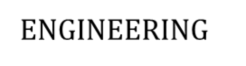

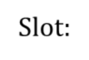

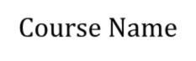
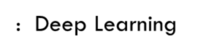
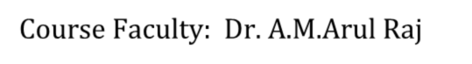


SIMATS ENGINEERING
Saveetha Institute of Medical and Technical Sciences
Chennai- 602105
Course Code: MLA0403
Course Name: Deep Learning
Course Faculty: Dr. A.M.Arul Raj
Slot: A
ONE PAGE WRITE-UP


Project Title: Deep Learning-Based Reinforcement Learning Adaptive Cybersecurity Defense System Using MTCNN for Mobile Devices in Deep Learning
Problem statement : Mobile devices face increasing cybersecurity threats such as malware, unauthorized access, and malicious network traffic. Traditional security systems mainly depend on fixed rules and may not effectively detect new and changing attacks. There is a need for an intelligent system that can identify normal and malicious activities accurately. Deep learning can analyze complex security data and improve threat detection.
Output 1 | Output 2 | Output 3
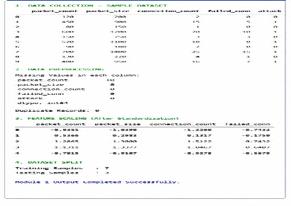 | 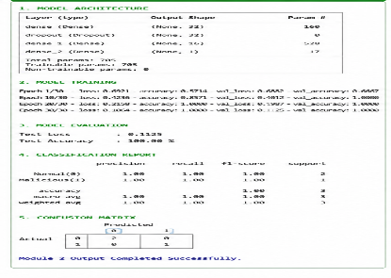 | 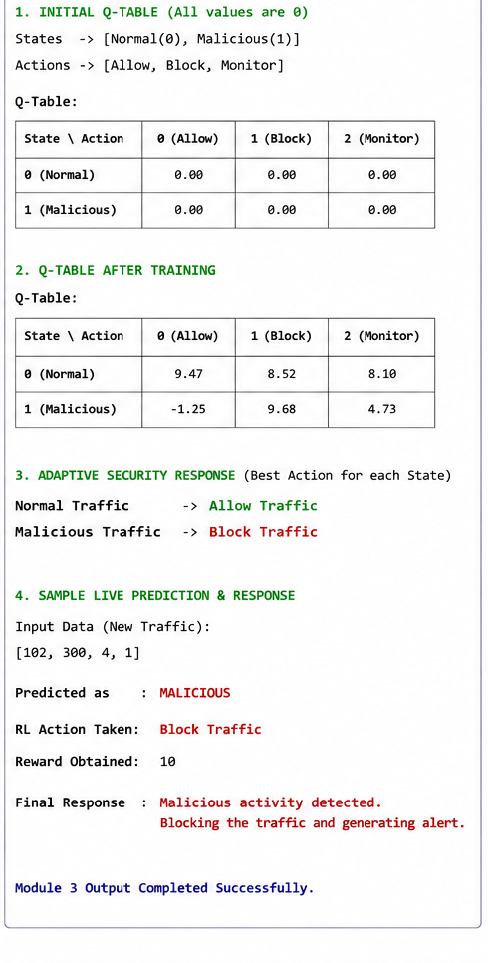
Student Contribution |  | Sample code
Student 1 : V Sunil Kumar (192425292) Student 2: Y Narasimha (192425281) Student 3 : M Sairam (192425291) |  | 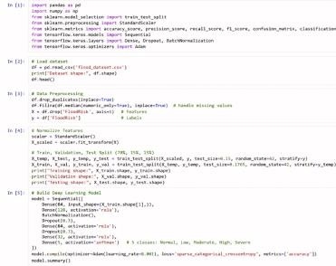
Project Description:
This project develops a Deep Learning and MTCNN-based cybersecurity system for detecting security threats in mobile devices.The system collects network traffic and security logs containing both normal and malicious activities.The collected data is organized, labeled, and prepared for model training and testing.I contributed to data collection, data organization, labeling, and checking the quality and reliability of the dataset.The prepared dataset supports accurate detection and classification of potential cybersecurity threats.

PLUG REPORT:

